Name: Hyun Seung Choi

Student ID : 000917943

The next page contains the diagrams.

**DA Project System Use Case Diagram.**

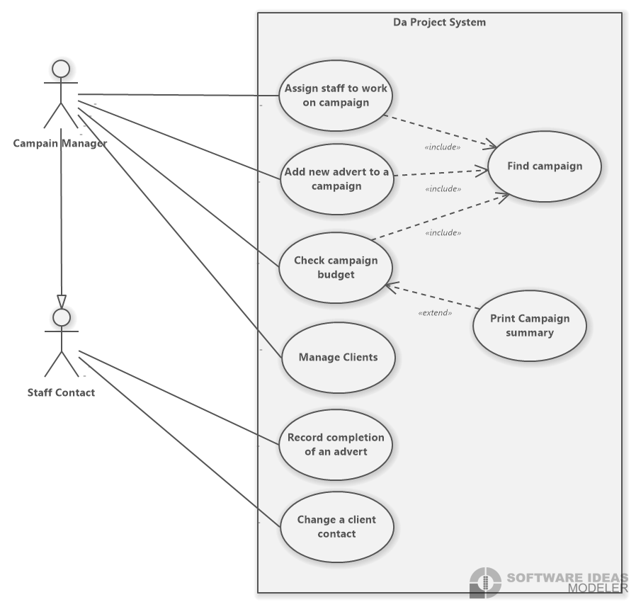

**The Class Diagram**

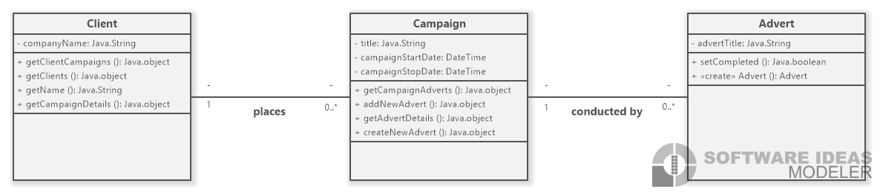

**The Analysis-level Sequence Diagram**

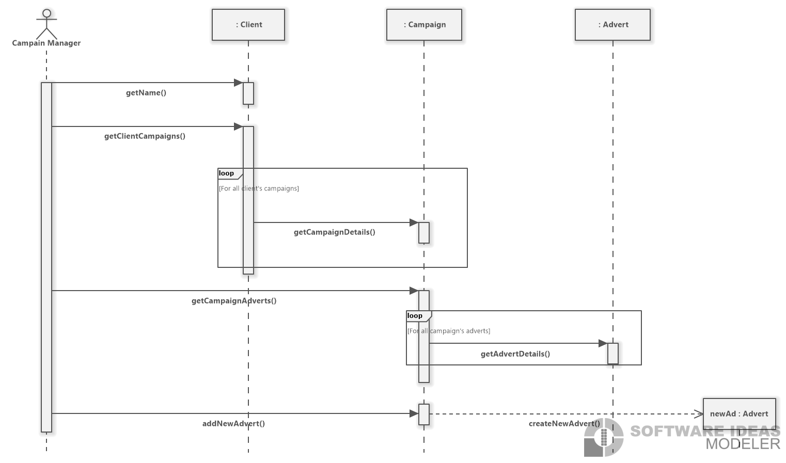

**The State Machine Diagram**

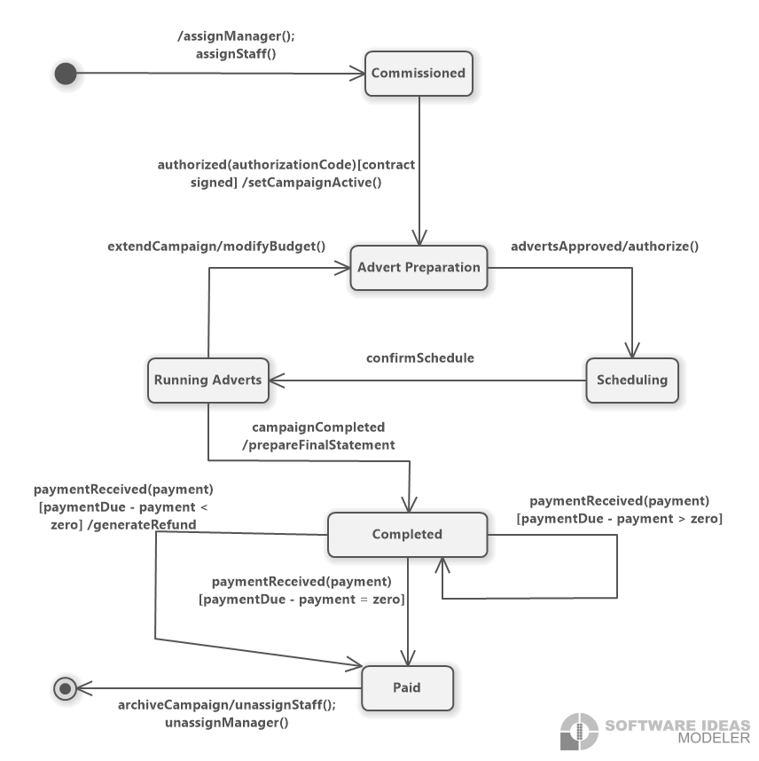

**The Design-level Sequence Diagram**

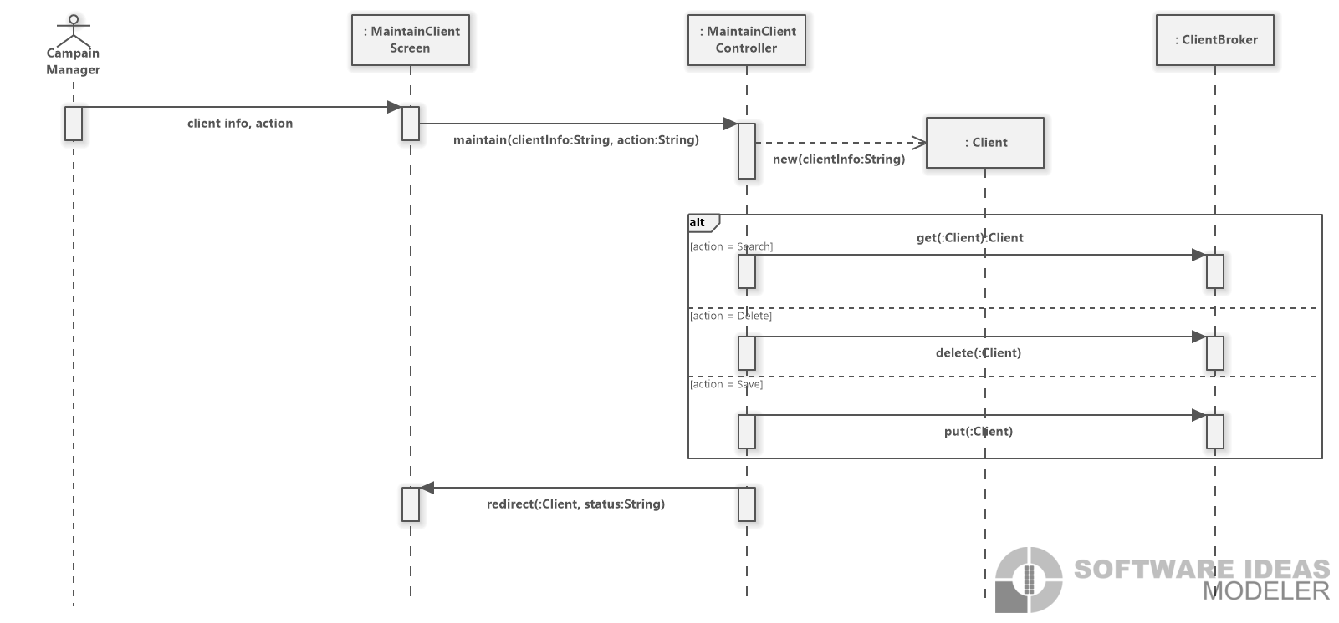

**The Activity Diagram copied from PROJECT2**

